GSK & ViiV Healthcare Australia Gender Pay Gap Explanatory Statement - 2024

Fair pay is a key element of the GSK and ViiV Healthcare culture. and we have strong systems in place to ensure that pay practices in all the countries we operate, ensuring our people receive fair and equitable pay and are rewarded for the work they do reflecting industry benchmarks, skills, performance and experience.

We also support the increased transparency that comes through the publishing of company gender pay gap data in support of pay equity. Like many companies in Australia, we have work to do in this area.

The 2022/23 reporting period was submitted at the time prior to the closure of our Boronia manufacturing site which ceased production in December 2022. These results should be read having regard to GSK and ViiV Healthcare Australia having a commercial, R&D and manufacturing employee population.

What is the difference between gender pay and equal pay?

“Gender pay” is very different from “Equal Pay”. Although these terms sound similar, they are often confused, so it’s very important to distinguish them.

“Equal Pay” is achieved through a consistent use of salary benchmark data and other factors like experience, performance and market forces to determine salary for roles, none of which consider individual characteristics such as gender.

“Gender Pay” is calculated as the difference between the rate of pay of male employees and that of female employees. It is expressed as a percentage of the rate of pay of male employees which is referred to as the gender pay gap. It is a measure across all our jobs in Australia, not of the difference in pay between men and women for doing the same job. Gender pay gap analysis looks across the workforce without regard for the specific roles, experience, performance or grade levels of employees.

The GSK and ViiV Healthcare Australia gender pay gap for the 2022-23 reporting period is explained largely by differences in representation during the reporting period at each level of the organisation, in particular the high proportion of women overall in GSK and at the mid-management and professional levels of the organisation, with a more even balance at senior levels.

Gender Pay Gap Over time – Median Measures

A positive percentage indicates a pay gap in favour of men.
Total Remuneration includes base salary, superannuation, bonus, allowances, one-time payments and long-term incentives.

All Employees | 2020-2021 | 2021-2022 | 2022-2023
Median Total Remuneration | 8.6% | 7.0% | 7.9%
Median Base Salary | 7.3% | 4.7% | 3.5%

Year on year reduction in the percentage difference in median base salary from 2020/21 to 2022/23 is reflective of our continued focus on building more gender balance in upper middle and upper quartiles of the organisation. Median total remuneration has remained more stable and is indicative that greater progress needs to be made in female representation in roles in the upper quartile specifically where earning potential is highest through participation in long-term incentive programs and greater bonus opportunity, particularly in years when GSK’s bonus awards have been above target.

Across the four quartiles of the organisation, female employees represent between 52%-64% of employees and 62% of Australian employees overall. The distribution below supports the hypothesis that to improve gender pay balance we need to continue to support our initiatives to increase female representation in the higher end of the upper quartile. The lower quartile also shows a higher pay gap which may be explained in part by highest proportion of female workers.

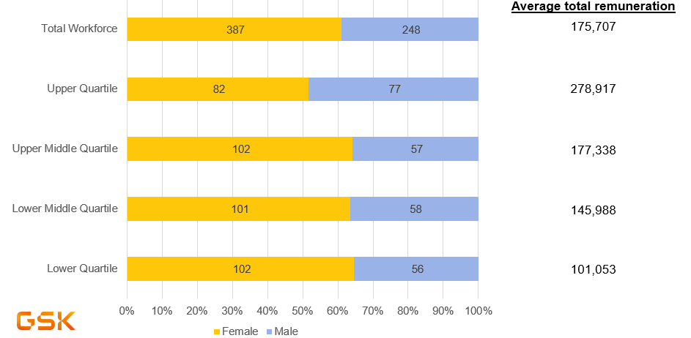

Key Management Personnel (KMP) and Managers

The guidance from Workplace Gender Equity Agency on the definition of KMP to “have the authority and responsibility for planning, directing and controlling activities of an entity…. (with) a defining feature of KMPs is (that) their influence is at the entity level…. And participate in organisation-wide decisions”. For Australia this group is the ANZ Country Executive Board made up of SVP & General Manager - Australia (chair), Country Manager ViiV Australia, Head of Human Resources, Director Communications, Government Affairs and Market Access and the General Manager – New Zealand. All board members are male except for the General Manager – New Zealand.

The Australian Leadership Team who leads the local business operations has twelve (12) members of which 40% are female.

The gender balance in management roles across of GSK Australia has improved from 44% in 2020/21 to 48% in 2022/23

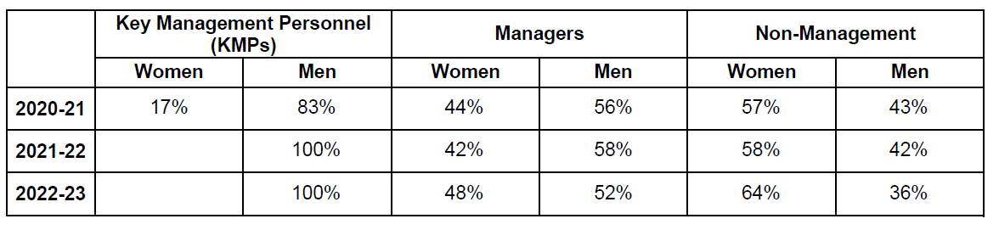

GSK Australia Gender Pay Gap – Key Priority Actions 2024

We are committed to taking meaningful actions to reduce the gender pay gap in GSK and ViiV Healthcare Australia.

We regularly review pay equity at various stages of the employment cycle (e.g. at hire, during the performance and reward process, and market reviews), making adjustments if necessary through our compensation processes. Our GSK Reward principles include a commitment to ensure pay practices are inclusive and not discriminatory, and we take this very seriously.

Additional key tactics in place to respond to our gender pay gap positioning:
- Clear development plans in place and mentoring for all unique successors for Australia priority leadership roles to accelerate “readiness”,
- Continued measurement of recruitment process to ensure gender balanced participation in the short-listing (those candidates presented to a hiring manager for consideration for a vacancy) and first round interview (those invited for a first-round interview with the hiring manager) stages,
- Continue to ensure that our manager practice and culture actively supports our key Inclusion and diversity policies notably our Parental Leave Policy & Care of a Family Member Leave Policy as well as psychological safety and growth mindset,
- Executive Sponsorship of the Australian Women in Leadership (WLI) employee resource group.

